Report on the Breeding and Keeping of 8 St. Lucia Amazons in the Breeding Facility of the Association for the Conservation of Threatened Parrots

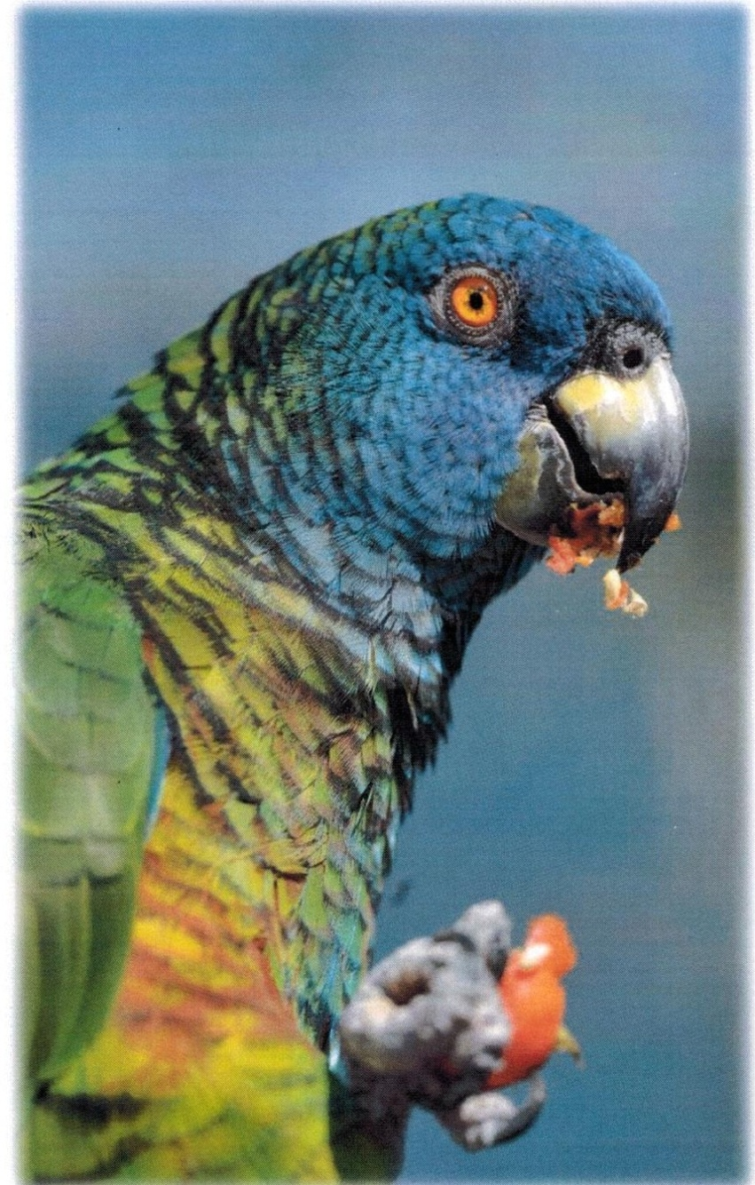

- in the framework of a breeding program for the St. Lucia Parrot in cooperation with the Forestry Department of St Lucia –

- May 2010 to December 2011 –

Outline
- Birds
- Pairing
- Accommodation
- Feeding
- Breeding
- Aviary Equipment/Employment
- Examinations
- Description of the Behaviour of the Birds
- Safety
- Care Staff
- Problems/Forecast

- Birds
Name | Breeding Book No. | Born | Chip Number | Ring Number | Sex | Access Date
Marley | B3962 | 29.05.96 | 956000002359594 | Jer194 | Female | 08.05.10
Joel | B4325 | 25.05.98 | -- | Jer158 | Male | 08.05.10
Clementia | B3684 | 13.05.95 | 956000002356695 | Jer184 | Female | 08.05.10
Hooligan | B1865 | 23.04.88 | 000009C7B1 | Jer178 | Male | 08.05.10
Beany | B4109 | 02.05.97 | 968000002497412 | -- | Male | 08.05.10
George |  | Unknown | 968000005452457 | -- | Male | 15.07.10
Rosita | B4326 | 27.05.98 | 0006 0DA55F | -- | Female | 20.05.10
Jabbah | B4293 | 24.04.98 | 006 ODC 10A | -- | Male | 20.05.10

On 8 May 2010 the Association for the Conservation of Threatened Parrots received 5 St. Lucia Amazons from Jersey in the context of a newly initiated breeding program with the government of St Lucia. The birds were taken immediately to the Clinic for Birds, Reptiles, Amphibians and Fish of the Justus-Liebig University Gießen to be examined and to be quarantined for a month. On 20 May two additional St. Lucia Amazons were fetched from Paradise Park in Hayle (UK) in the context of the abovementioned program and also taken to Gießen to the Justus-Liebig University for the purpose of entry examination and quarantining.
After all examinations were carried out and the birds had completed the isolation period, they were transferred to our breeding facility in Schöneiche.
A young bird which had fallen out of its nest in St Lucia and which would very probably not have survived the coming months because of the lack of veterinary opportunities was also integrated into the existing breeding program and was imported into Germany on 15 July 2010. It was brought to Quarantine Station BB-1 and stayed there for a month. It was then brought to our breeding facility in Schöneiche.

- Pairings
Based on the documentation of the previous keeper, we knew of the previous pairings of the birds. As, in our experience, Caribbean amazons incline greatly towards aggression, we changed nothing for the time being.
Thus accommodated in pairs were: Marley, female, with Joel, male
Rosita, female, with Jabbah, male

Accommodated singly for the present were: Beany, male
Hooligan, male
Clementia, female
George, male

Shortly thereafter we sought to pair Clementina and Hooligan, taking into account the genetic aspects and suitability for breeding. Following a familiarisation period of about 3 weeks in individual cages close together, during which the very strong aggression at the beginning decreased considerably, we brought both birds together without great problems.

After the young bird, which we received from St Lucia in July, arrived in our facility, we similarly proceeded to pair her off with other males. During the day, the birds were given the opportunity to get to know each other, in the evenings we put the young bird back into her own cages. This was done until we were certain that no aggressive behaviour was to be expected – even when the birds were not supervised.

During a later determination of the sex of the young bird, it turned out that she was also male. However, to provide both birds with company of the same type, we left both together.

Within the last six months “Clementina” has become ever more aggressive towards her partner “Hooligan”, she began to bite off the feathers on his neck, she allowed him to touch her only rarely and began to pluck herself a lot. This behaviour is known from the notes of the previous keeper (begun in 1997). That is why we decided to put a collar on the female and to separate the two birds. The male was put directly into the neighbouring aviary. In spite of these measures, the plumage situation of the hen worsened and we decided to put another collar on her and to pair her with another male.

“Jabbah” and “Clementina” were paired at the beginning of December.

“Hooligan” and the remaining female bird “Rosita” should be paired before the end of the year. Both are currently in the familiarisation phase and are very promising.

- Accommodation
The birds were accommodated in our breeding facility in Schöneiche until January 2011. There they lived in an inside aviary that can be heated - dimensions 2m by 2m, the height was 2.50m. Attached was a 2m wide, 2.50m high and 6m long exterior aviary.
All birds, apart from one pair, were transferred to the new breeding facility in Tasdorf. There they occupy a 2m wide, 3.50m deep and 3m high, heated inside aviary and they can use the 2m wide, 10m long and 3m high exterior aviary.
One pair was transferred to the new facility after the end of the brood-business.
The last pair was transferred to the new facility in Tasdorf at the end of September.
- Feeding
The blue masked amazons are currently being fed three times daily. The first feed is handed out between 8 and 9 in the morning and consists of fruit, vegetables and a very small amount of cooked peas. The second feed is given at 12:30 p.m. and is made up of fruit and vegetables. Fruit, vegetables and a very small amount of pellets are given in the last feed at about 4:30p.m.
The number and ingredients of the individual feeds reflect the experience of the previous year and a half and, in our opinion, is the best way to feed the birds according to their needs.

Concerning this, we would like to mention that the birds we received from DWCT in Jersey and from Paradise Park in Hayle were, apart from one bird, very adipose and not suitable for breeding. The female “Marley” was adipose, had no tail feathers, no wing feathers and was plucked on the neck and stomach. The female “Clementina” was adipose and plucked on the whole breast and on the stomach as well as on the wings. The female “Rosita” was adipose. All hens, apart from “Hooligan”, were adipose.

In order to bring the birds to a breeding condition, with the help of the notes of the previous keeper, we worked out feeds made up of fruit and vegetables in the morning and in the evenings of a mixture of seeds without high-fat seeds. Regular weight controls showed that there were no weight reductions with this feed. We replaced the seeds mixture with a cooked feed made up of various pulses. This type of feed did not lead to the desired result either. So we replaced the cooked feed with germinated legumes. This brought about the desired weight reduction.
All the birds receive animal protein once a week in the form of boiled eggs and soft cheese. In order to safeguard the supply of vital vitamins and minerals, we offer various products from Nekton and other well-known producers.
During the breeding period, the brood pairs are given a higher fruit content, protein and special vitamins as well as increased mineral doses 2 to 3 times a week.

- Breeding
The amazons came to us in 2010 after the breeding season. So we were unable to record any breeding activity in the first year.
In 2011 only the pair “Marley” and “Joel” was ready for breeding. The hen laid 3 eggs.
- Egg laid on 16.5, well incubated at the beginning, destroyed in the afternoon
- Egg laid on 19.5, replaced by an artificial egg, incubated in the incubator
- Egg laid on 19.5, replaced by an artificial egg, incubated in the incubator
Unfortunately neither egg was fertilised, which didn’t surprise us, as the female had only two tail feathers at the time of copulation and successful copulation was therefore unlikely.
The pair “Clementina” and “Hooligan” displayed an interest in the nesting box from December 2010 to mid-February 2011, but not really, however, for the breeding time.
The pair “Rosita” and “Jabbah” was not interested in either the nesting box or in the partner bird.

- Aviary Equipment/Employment
The aviaries for the St. Lucia Parrots have the following dimensions
Inside space - 2m wide x 3.5m deep x 3m high
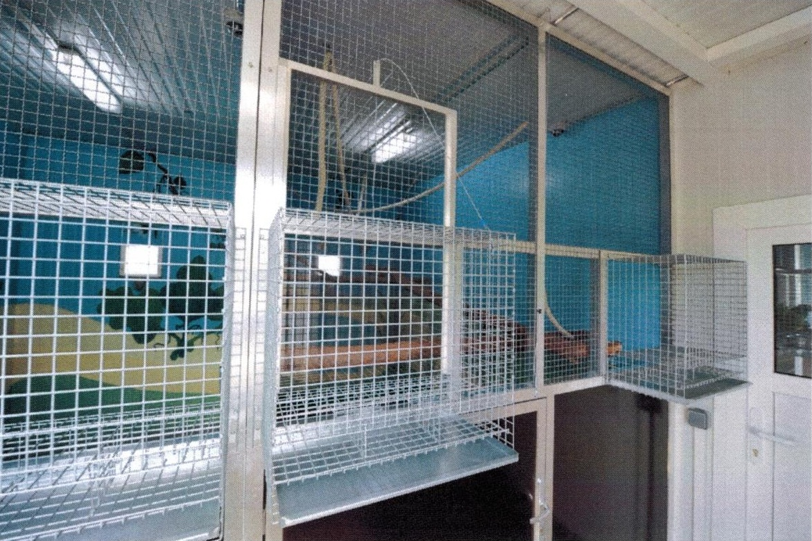
The interior space can be heated, the floor furnished with a sand litter.

Exterior - 2m wide x 10m long x 3m high
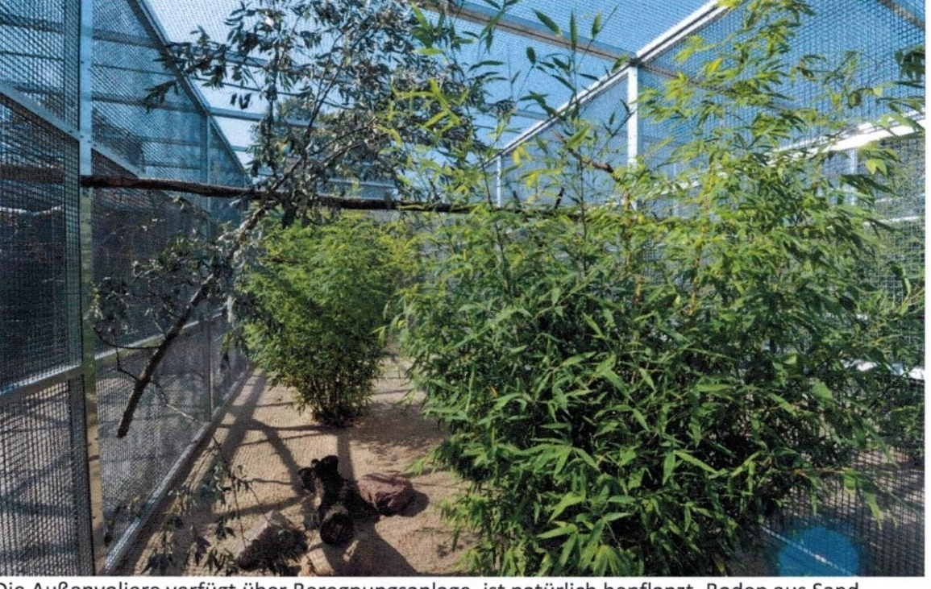
The exterior aviary has overhead irrigation, is planted with natural plants, a sand floor.
As a natural enrichment each interior space is furnished with fresh twigs and branches for chewing on, which are regularly renewed. In addition, we offer ropes, play toys in the form of empty coconut shells, hollow branch cuts and play toys developed especially for the birds.
The exterior aviaries are also regularly equipped with fresh materials for chewing on and playing with.
- Examinations
On arrival the birds are examined for chlamydia, avian influenza, mycoplasmas, psittacosis, herpes virus, polyomavirus, circovirus, parasites and salmonella. X-ray images are prepared and a blood chemistry examination carried out.
If requested, copies of the results can be made available to the Federal Office for Conservation or the Forestry Department of St. Lucia.
Conspicuous in almost all the birds is an increased intake of water. To find out the reason of this and to recognise the organic causes, x-rays were taken of two of the birds, a CT scan and endoscopy carried out and new blood analyses carried out at the Institute for Avian Illnesses in the University of Applied Sciences, Berlin. No organic causes could be found; and no cause could be found from the blood analyses.
The birds regularly receive cranberry extract to support the kidney functions. Because of the poor results of the x-ray examinations at the arrival of the birds, they have been receiving milk thistle seeds since then to support the liver functions.

- Description of the Behaviour of the Birds
Outside the breeding time, only occasional aggression is to be seen between them. Aggression takes place almost exclusively during feeding. However, we are able to avoid this via the separated feeding of the individual birds, because each inner space for the Caribbean Amazons has two feeding tables. Occasional power struggles amongst well brought together pairs are thus no more often to be seen than in other parrots.

- Safety
The breeding facility is monitored by the most modern and reliable technology. There is a camera in each interior aviary, which records the behaviour of the birds. Direct remote monitoring is possible via PC or over the phone. It is thus ensured that it is possible to intervene at any time if necessary. Furthermore, the nesting boxes are monitored by a separate camera. It can thus be seen whether natural breeding is possible or whether the parent birds are too nervous or inexperienced for the breeding-business. Hence we can reduce the damage to the eggs by the parent birds to a minimum.

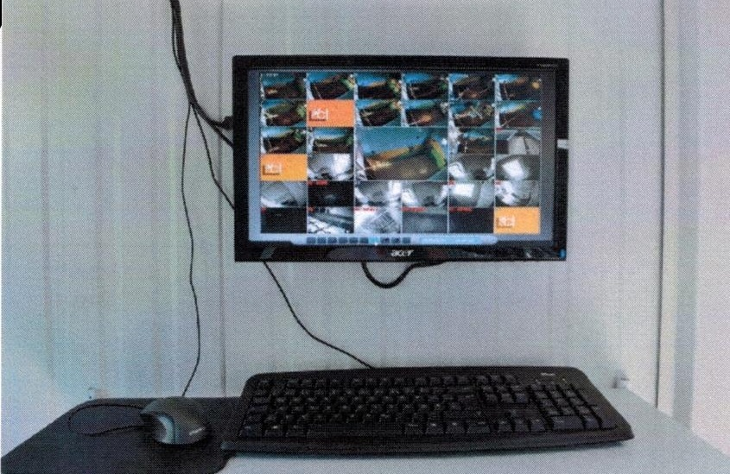

Camera monitoring of the aviaries

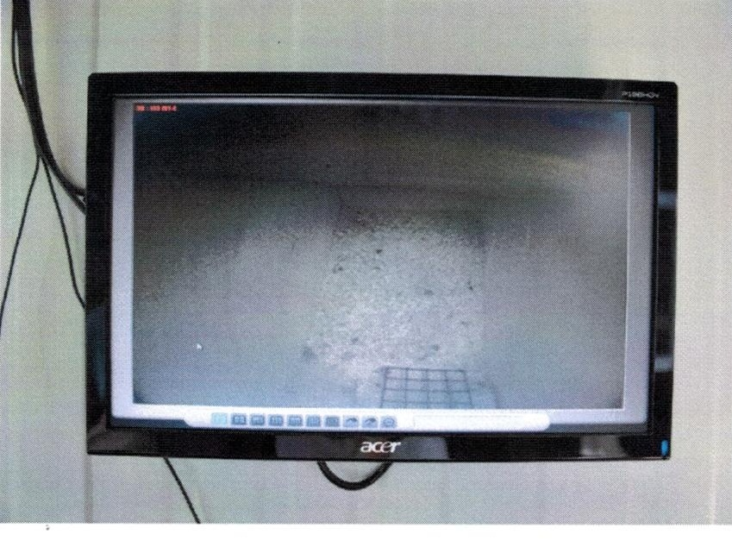 Nest boxes monitoring

Exterior facility monitoring
- Care Personnel
Martin Guth - has bred his own parrots since early childhood
Enrico Sydow - employed for 5 years, experience with parrots since childhood via parrot breeding in the family
- trained at Al Wabra Wildlife Preservation in Qatar
- various participation in further training courses

Sebastian Laurich - employed as a bird keeper since April 2011

Marcel Liebe - employed as a bird keeper since August 2011

- Problems/Forecast
To summarise, we would like to state that the previous year and a half was used to get to know the requirements and special character of the birds. With the exception of one male bird, all the birds received from Jersey and Hayle were in a physical state that required improvement and were not in a breeding condition. We were able to sort out the problem of overweight. Since then we have been working increasingly on the plumage problem of the female birds in order to recover their ability to fly and to enable them to copulate successfully.
We are confident that we will achieve this in the coming or the next following breeding season 2012 or 2013 which makes us confident to expect offspring then.

Prepared on 19.12.2011
<<Signature>>
Association for the Conservation of Threatened Parrots

